FUNCTIONAL REQUIREMENT

Product Name : OpenCart E-commerce (Frontend)

Prepared By: Mofizul Islam Bijoy

Prepared Date: Feb 15, 2026

Overview

OpenCart is free open source e-commerce platform for online merchants. OpenCart provides a professional and reliable foundation from which to build a successful online store. This foundation appeals to a wide variety of users; ranging from seasoned web developers looking for a user-friendly interface to use, to shop owners just launching their business online for the first time. OpenCart has an extensive amount of features that gives you a strong hold over the customization of your store. With OpenCart's tools, you can help your online shop live up to its fullest potential.

Requirements

OpenCart requires certain technical requirements to be met for the store to operate properly. First, a web server must be created to make the OpenCart store publicly available on the web. Domain names and hosting services can easily be purchased for an affordable price.

When selecting a hosting service, you should check to see that these server requirements are provided and installed on their web servers:

These extensions must be enabled for OpenCart to install properly on the web server.

• PHP 5.4  
• jQuery 2.1.1  
• JavaScript  
• Database (MySQL suggested)  
• Web Server (Apache suggested)

Opencart Frontend

This Document is intended to be used as an introduction to the OpenCart default store front. The store front reveals how the customer views and interacts with the store.

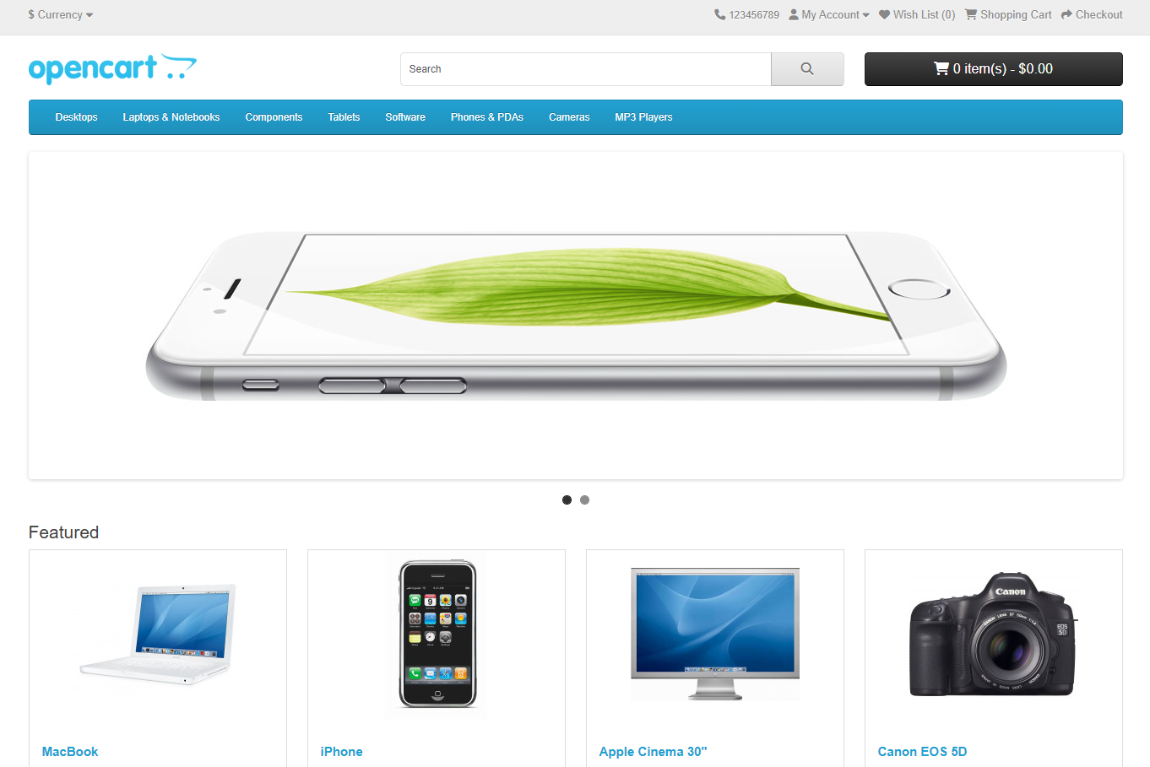

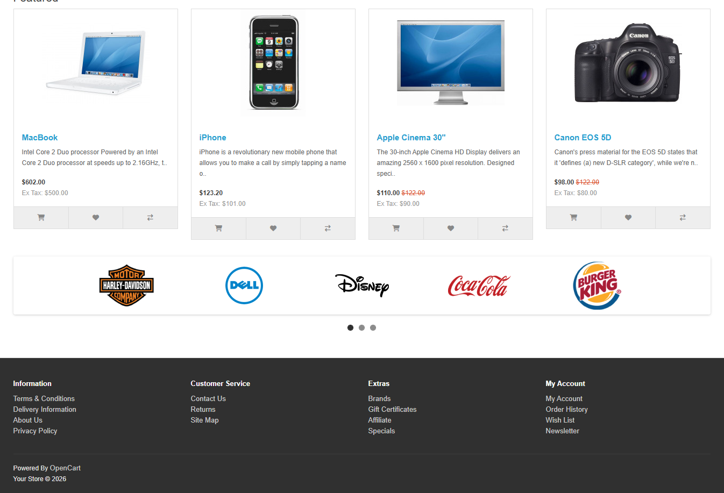

**Navigating the shop**

The OpenCart default theme makes navigating a shop's products easily accessible to its customers.

**Home page**

The home page is arguably the most important page in the shop, in terms of presentation. In most cases, this will be the first page that a customer interacts with (especially if they are directed to the store site from a search engine). The shop's homepage needs to be user-friendly, while at the same time highlighting the shop's products.

The first step in becoming familiar with the store front is understanding the anatomy of the OpenCart default homepage.

**The header**

The header will be displayed at the top of the page, on every page of the store; not just the home page.



The header has the following navigation options:

Store logo: Clicking on this logo will direct the customer back to the home page of the store.  
Currency block: The customer can select which currency the store's products will be in by clicking on any of the currency icons.  
Shopping Cart: Displays the number of items purchased, and the total price of the order. Clicking on the button will containing all of products added to the cart and an option to "View Cart" or Checkout.  
Search box: The customers can type in the search box to search for a product within the store's product categories.  
Links: Links the customer to the Home page, Wish List, My Account, Shopping Cart, and Checkout.  
Telephone: Company telephone number.  
My Account: Customer can register or login from here.

**The top menu**

The top menu category only displays the top parent categories of products.

Like the header, the top menu will be displayed on every page. When the customer's mouse is dragged over a category, a drop-down menu will display the sub-categories for that parent category.



* Desktops
* Laptops & Notebooks
* Components
* Tablets
* Software
* Phones & PDAs
* Cameras
* MP3 Players

When a parent category is clicked, the customer will be directed to the category page, which displays all the products within that category.

**Slideshow**

The slideshow displays several product banners of your choice by alternating the images in a slideshow. After a certain amount of time, one banner will shift to the next banner. Banners in this slideshow are useful for highlighting certain products to be easily accessible by the customer. When the banner is clicked on, the customer will be directed to the product on the banner's page.

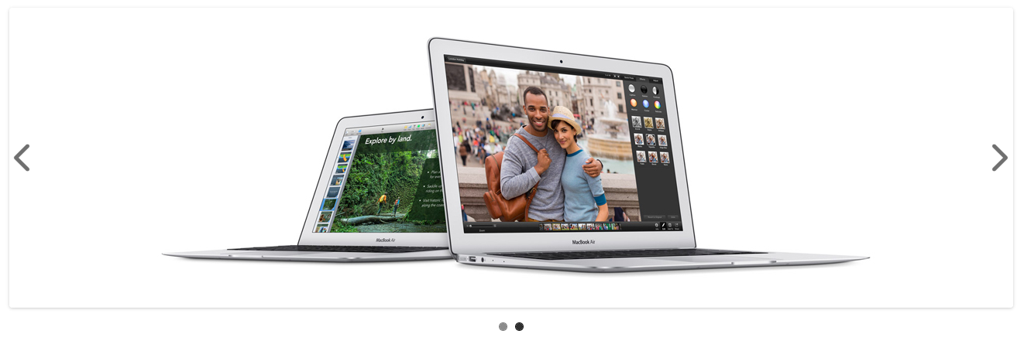

Unlike the top menu and header, the slideshow in the OpenCart default can only be viewed on the home page in this position.

**Featured products**

OpenCart gives you the option of featuring specific products of their choosing on the home page.

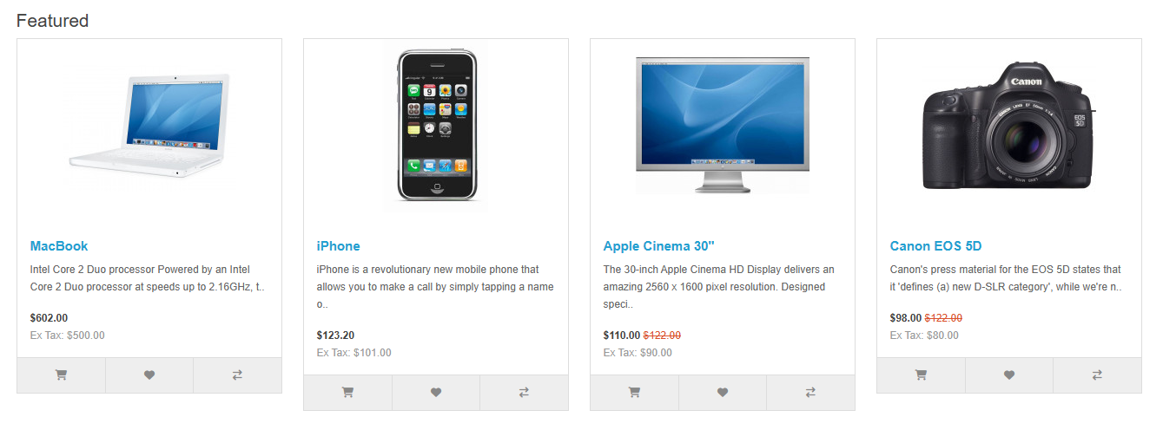

**Featured Brands**

OpenCart gives you the option of featuring specific Brands of their choosing on the home page.



The Featured Section includes the Brand image, and its hit directly to their dashboard.

>> The Carousel is only located on the Home Page in the default.

**Footer**

The footer is located at the bottom of every page, not just the Home Page. This block of miscellaneous links is useful in sorting relevant pages for the customer that may not logically sort anywhere else.

The organizational scheme of the footer can be divided into the following sections:

• Information: "About Us", "Delivery Information", "Privacy Policy", "Terms & Conditions"  
• Customer Service: "Contact Us", "Returns", "Site Map"  
• Extras: "Brands", "Gift Vouchers", "Affiliates", "Specials"  
• My Account: "My Account", "Order History", "Wish List", "Newsletter"

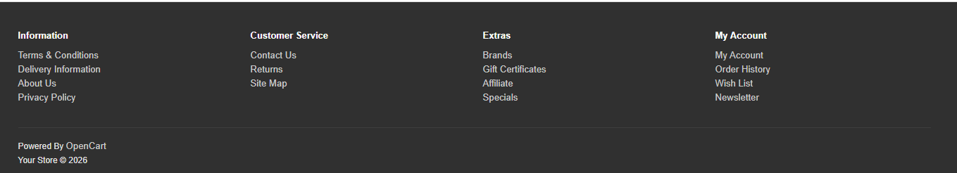

**Product Pages**

The opencart default product page will follow the structural format see below.

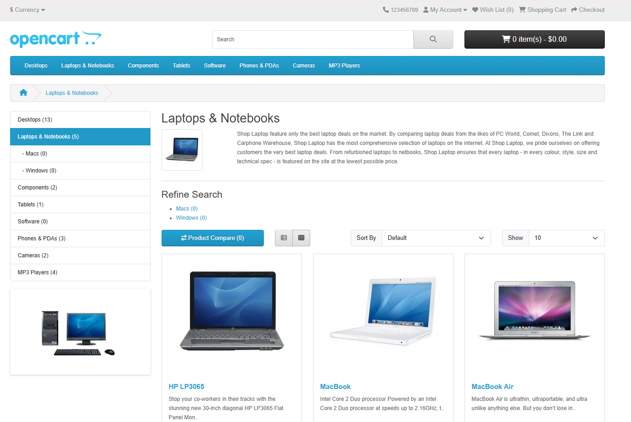

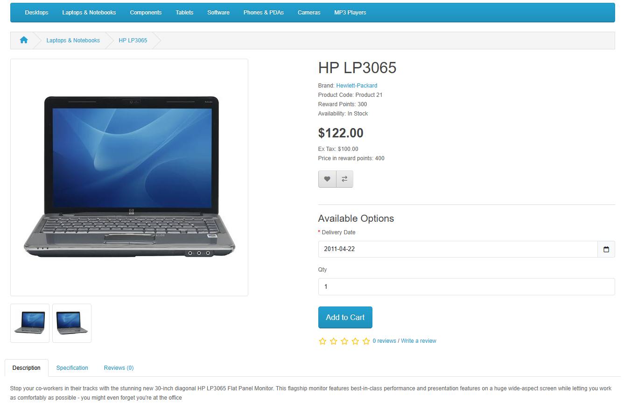

The product page can be divided into the following sections:

• **Product image:** The product image can be displayed under the title on the left-side, along with alternate views of the product underneath it in smaller boxes. Clicking on the main image will expand the image within the window for the customer to see it in greater detail.

• **Product details:** The product code, availability, and price are displayed just right to the product image.

• **Cart:** The customer can select a quantity and add the product to their cart, wish list, or compare.

• **Rating/Sharing:** Underneath the cart can rate the product and/or share the product on different social media websites.

• **Description tab:** An area underneath the main product information to provide a detailed description of the product.

• **Review tab:** An area for the customer to write a review on the product.

**Category product listings:**

Category product listings enable customers to browse products similar to other products within the same category. This is especially helpful for customers looking to compare products, a feature that will be explained under Categories. The category page can be accessed a number of ways. It can be accessed from the top menu, when a customer clicks on one of the parent categories. Also, on product pages a customer can access the category product listing page by clicking on a category on the left side category block.

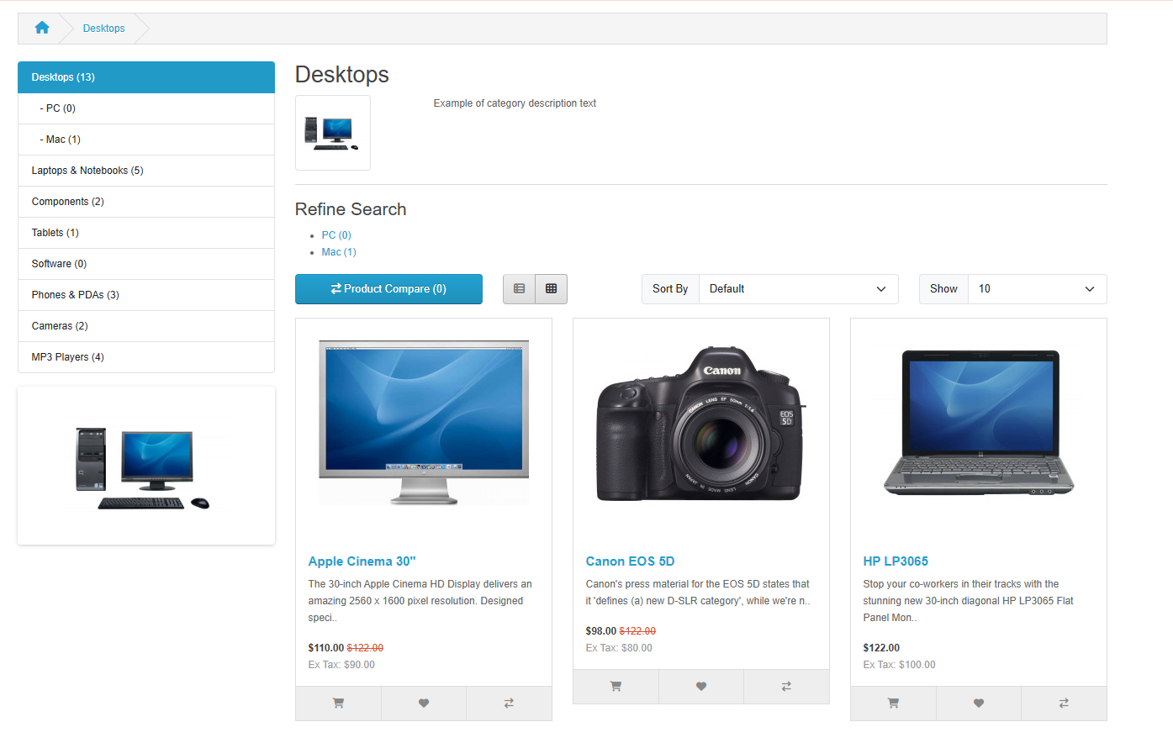

As seen above, the category block is displayed on the left-side like it is in the product page. There is space under the Category title at the top to add a description to the category. The "Refine Search" links to sub-categories of that category for the user to browse. The products can be displayed according to the customer's preference: in a list or grid. The above image is sorted in the listing format. The products can be sorted according to name, price, rating, or model in the "Sort By" box.

The number of products displayed in the product listing can be changed in "Show" from 15 up to 100.

There is a section that gives space for each of the products within the category, providing a product image, description, price, and an Add to Cart option. There is an option to add the product to a wish list. Another option for the product is to "Add to Compare".

**Product compare**

The "Add to Compare" feature in the product section allows the customer to compare the different specifications, features, and price of a number of products s/he might be interested in.

**Product Comparison**

Product comparison is a useful feature that helps customers make better buying decisions. It allows users to select multiple products and view their specifications, features, and prices side by side. Instead of opening different product pages and remembering details, customers can easily see the differences in one place.

This feature is especially helpful when products are similar, such as mobile phones, laptops, or home appliances. By comparing important details like price, size, performance, ratings, and availability, customers can quickly identify which product best meets their needs and budget.

A good product comparison page should be clear and well-organized. Information is usually displayed in a table format, where each product appears in a separate column and features are listed in rows. This layout makes it easy to scan and understand differences. The option to add or remove products from the comparison list should also be simple and user-friendly.

Additionally, the comparison feature should work smoothly without errors. The correct product information must be displayed, and updates in price or stock should be reflected accurately. The page should load quickly and work properly on different devices such as mobile phones, tablets, and desktops.

Overall, product comparison improves the shopping experience by saving time and helping customers make confident decisions. It adds value to an e-commerce website by making product selection easier and more transparent.

Shopping Cart

A shopping cart is a feature that allows customers to add, review, and manage products before completing a purchase. It displays selected items, quantities, prices, and the total amount, making the checkout process simple and organized.

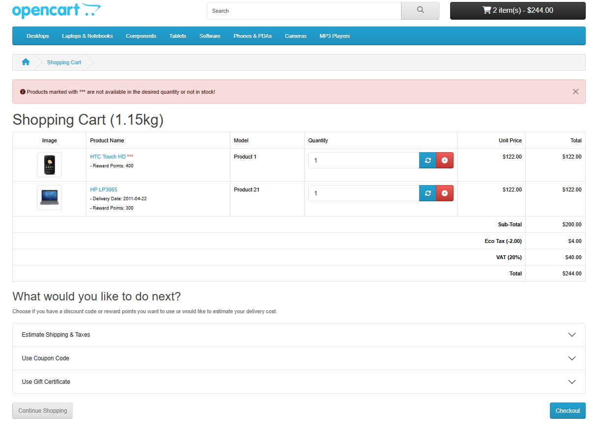

The shopping cart process begins when a customer selects a product and clicks the “Add to Cart” button. The selected item is then stored in the cart along with its details, such as product name, image, model, unit price, and quantity. Customers can view all added items in the shopping cart page, where they can update quantities, remove products, or continue shopping.

The cart automatically calculates the subtotal based on the selected products and quantities. Additional charges such as taxes, eco tax, and shipping fees may be applied and displayed clearly. If available, customers can also apply coupon codes, gift certificates, or reward points to receive discounts.

Before proceeding to checkout, users can estimate shipping and taxes to understand the final payable amount. Once satisfied with their selections and total cost, the customer clicks the “Checkout” button to continue with billing details, shipping information, payment method selection, and order confirmation. This process ensures a smooth and organized purchasing experience.

# Checkout

The checkout process is the final step in completing an online purchase. It begins after the customer reviews the shopping cart and clicks the checkout button. At this stage, the user can either register a new account, log in, or choose guest checkout.



The customer must enter personal details such as first name, last name, and email address. Next, shipping information is provided, including address, city, postcode, country, and region. After entering the required details, the user selects a shipping method and a preferred payment method.

The order summary is displayed on the same page, showing product details, subtotal, taxes, and the final total amount. Customers may also add comments related to their order before confirming. Finally, the user agrees to the privacy policy and clicks the “Confirm Order” button to complete the purchase. This structured process ensures accurate information collection and secure order placement.